**SQL:**

Total Marks: 40

Each question 10 marks

**Question: 1**

Given the following tables:



What will be the result of the query below?

**SELECT** * **FROM** runners **WHERE** id **NOT** **IN** (**SELECT** winner_id **FROM** races)

Explain your answer and also provide an alternative version of this query that will avoid the issue that it exposes.

**Output:**

Output will only have rows from runners for which Id is not present in races table.

It will try to find out rows such that id !=2 and id!=3 and id!= Null. Since and condition will always fail at last clause i.e. id != Null, it will return zero rows

Alternate query:

**SELECT** * **FROM** runners **WHERE** id **NOT** **IN** (**SELECT** winner_id **FROM** races where winner_id is NOT NULL);

**Question: 2**

Given two tables created as follows



Write a query to fetch values in table test_a that are and not in test_b without using the NOT keyword.

Query:

Select * from test_a MINUS select * from test_b;

This will return all the rows from test_a which are not there in test_b

**Question: 3**

Given the following tables:

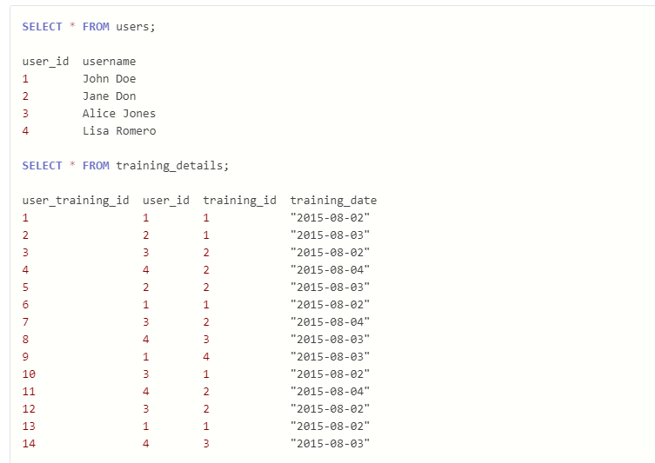

Write a query to to get the list of users who took the a training lesson more than once in the same day, grouped by user and training lesson, each ordered from the most recent lesson date to oldest date.

Query:

SELECT u.username, t.tranning_date, COUNT(t.training_id)

FROM users u

INNER JOIN training_details t ON(u.user_id = t.user_id)

GROUP BY u.username, t.training_id, t.tranning_date

HAVING COUNT(t.training_id) > 1

ORDER BY tranning_date DESC

**Question: 4**

Consider the Employee table below.

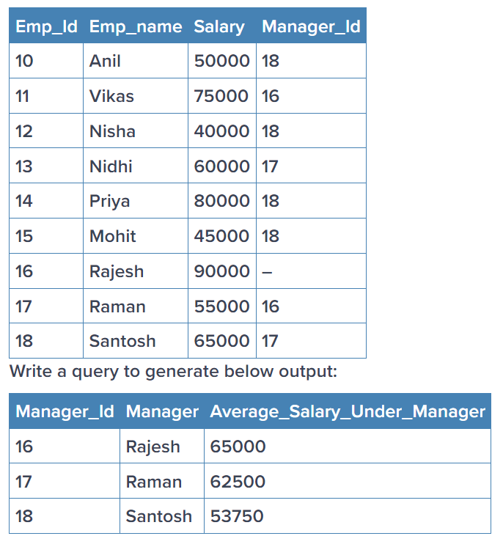

Query:

SELECT Manager_Id,Manager, avg(Salary) as Average_Salary_Under_Manager

FROM Employee

GROUP BY Manager_Id